 | Faculty of Computer Science and Mathematics

Lab Exercise 4

Name: | Nur Aqilah Syahirah Binti Ahmad Tajuddin
Matric Num: | S80850



Overview:

This in-class exercise extends Lab Exercise 4. You will apply HTML5 page structure elements, embed a video using the <video> tag, and use CSS (internal and external) to style a web page. You will practise CSS syntax, ID and class selectors, a CSS navigation bar, text decoration and link states (:link, :visited, :hover, :active).
There are two problems. Your lecturer will assign one problem to you, or you may be asked to complete both.

Learning Outcomes
- Utilize semantic HTML5 elements to create a well-structured web page layout.
- Embed video content using the <video> and <source> tags.
- Apply CSS syntax using internal and external style sheets, with ID and class selectors.
- Build a functional and visually appealing navigation bar using CSS.
- Use text-decoration and link states to improve text presentation and user experience.

Best of luck!

Problem A: Visit Terengganu – Tourism Promotion Page

The state tourism office wants a simple promotional web page to attract students and visitors to Terengganu. The page must look attractive, have a working navigation bar, show a promotional video, and include a trip interest form. Build the page using HTML5 and CSS (both internal and external CSS). You may choose any destinations, prices and video.

Instructions
Create two files named lab4_ExerA.html and style.css that contain the following:

HTML5 Page Structure
  - Use <!DOCTYPE html>, <meta charset="utf-8"> and <meta name="viewport" content="width=device-width, initial-scale=1.0">.
  - Structure the page using <header>, <nav>, at least three <section> elements with ids (e.g. destinations, video, trip) and a <footer>.
  - In the Destinations section, use at least three <article> elements. Each article has an
<h3> (place name), a short <p> description and a promotion price.
  - Add a <meter> element showing how many trip seats have been filled (e.g. min="0" max="40" value="28").
  - In the footer, add &copy; and an <address> element with an e-mail link (mailto:).

Navigation Bar
  - Create the navigation bar using an unordered list (<ul>, <li>, <a>) with links to each section (e.g. href="#video").
  - In style.css, remove the bullets (list-style-type: none), remove the underline from the links (text-decoration: none), and set background-color, padding, text-align and text-transform: uppercase.
  - Change the background colour of a menu item when the mouse is over it (:hover).

Insert Media (Video)
  - Embed a video in the Video section using <video> with width, height and controls, a
<source> with the correct type (e.g. video/mp4), and fallback text for browsers that do not support video.
  - Add a caption below the video (e.g. using <figure> and <figcaption>, or a <p class="caption">).

CSS Styling (Internal and External)
  - Link style.css using <link rel="stylesheet" href="style.css">. Most of your styles must be in this file.
  - Add a <style> block in the <head> (internal CSS) with at least two rules for this page only.
  - Use at least two ID selectors (e.g. #destinations) and at least two class selectors (e.g.
.card, .price, .center).

  - Use at least six different CSS properties, e.g. color, background-color, font-family, font-size, text-align, padding, border, width.

Text Decoration
  - Apply text-decoration to headings, e.g. overline for <h1> and underline for <h2>.
  - Show each promotion with an old price and a new price. Style the old price using a class with text-decoration: line-through (e.g. RM 299 crossed out, followed by RM 199).

Interactive Link States
  - Style a:link, a:visited, a:hover and a:active with different colours. Write them in the correct order (link → visited → hover → active) so that all states work.

Interactive Elements (Form)
  - In the Trip section, include a form with the following fields:
    - Name (text input) and E-mail (type="email")
    - Traveller type (radio buttons): Student, Staff, Public
    - Interests (checkboxes): Islands, Food, Culture, Nature
    - Submit button
  - Style the form using a class (e.g. .trip-form) with background-color, padding, border and width.

Responsive Design and Comments
  - Make the page fit small screens: use percentage widths (e.g. width: 90%) and make the video scale with video { max-width: 100%; height: auto; }. Test by resizing the browser window.
  - Use comments to explain each section of your HTML (<!-- ... -->) and CSS (/* ... */) code.

Submission
Save the files as lab4_ExerA.html and style.css, validate the HTML at https://validator.w3.org and the CSS at https://jigsaw.w3.org/css-validator (Validate by File Upload), and submit them (Submit lab4_ExerA.html, style.css and Screenshot of validation) through Github > Update your index.html (if you are hosting your lab in Github pages)

Codes

labExer4.html

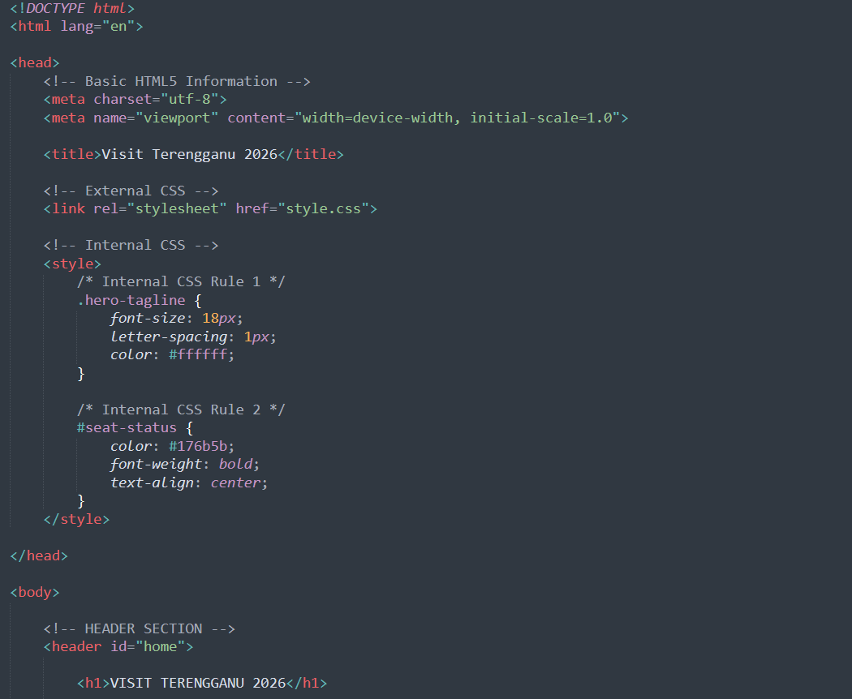
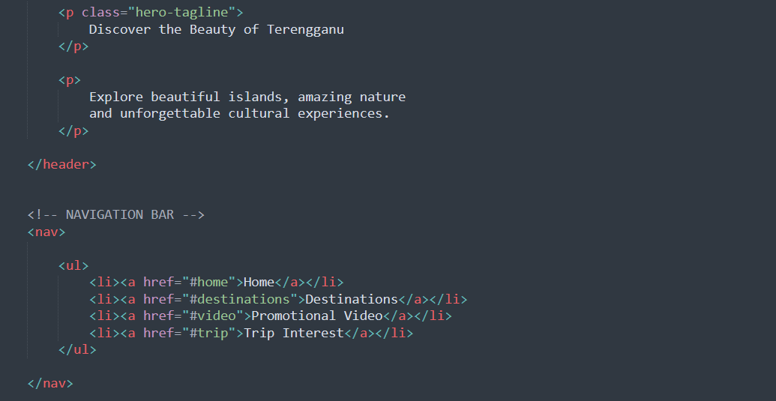

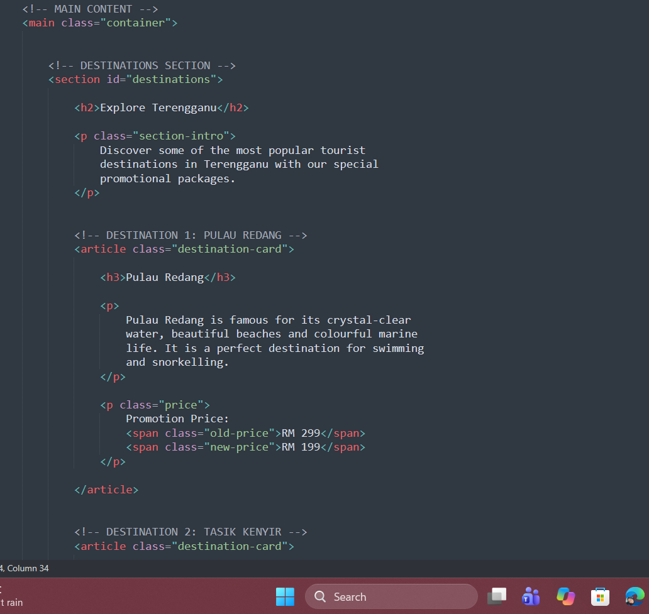
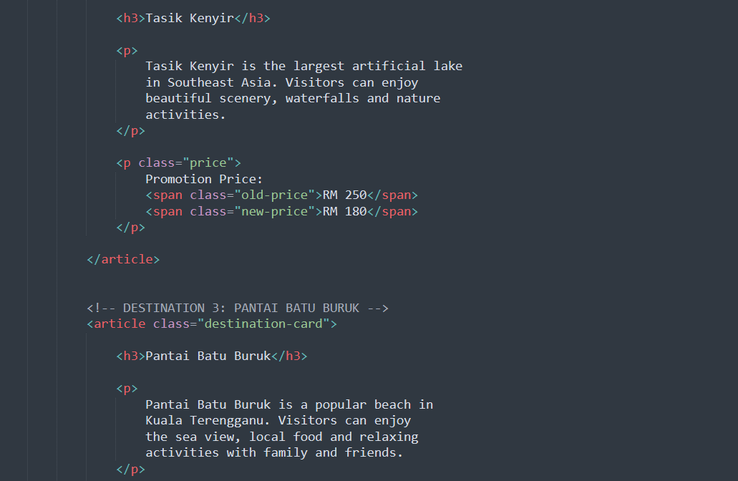

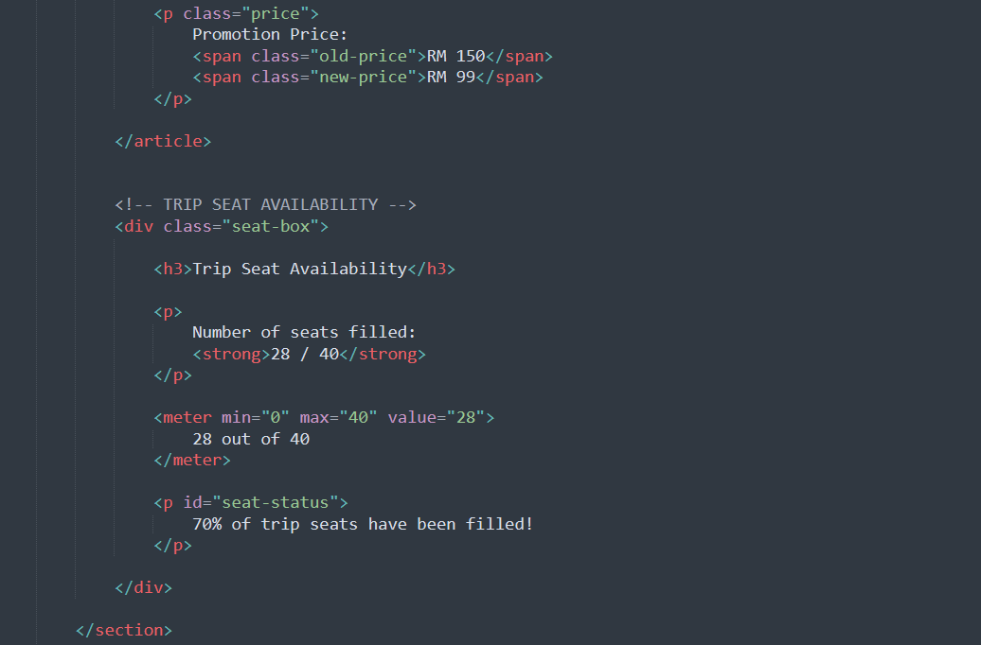
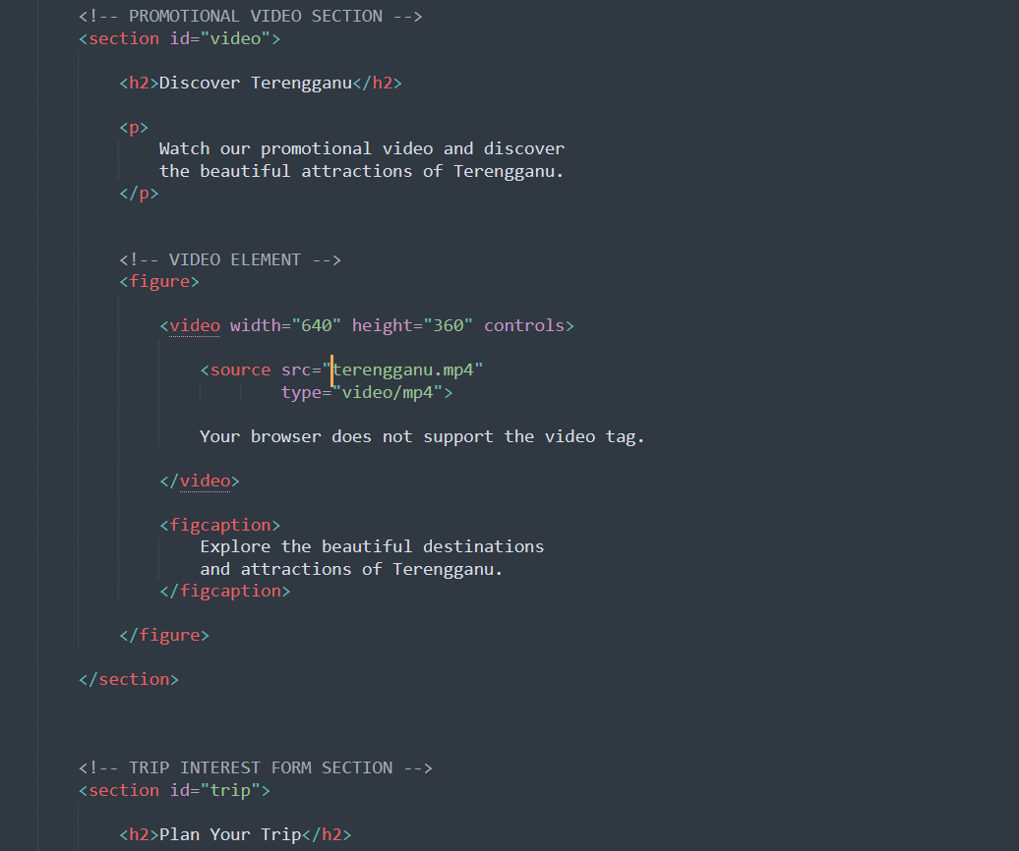

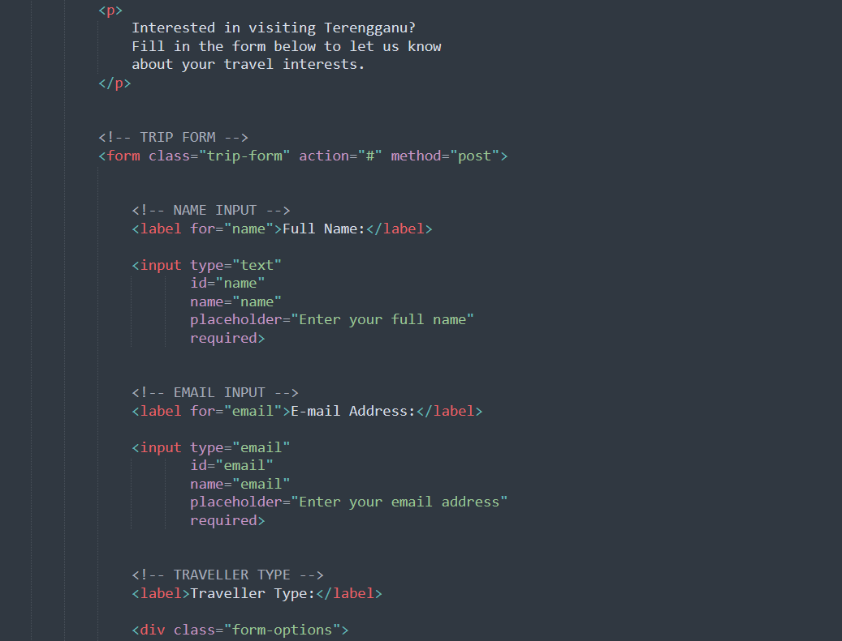
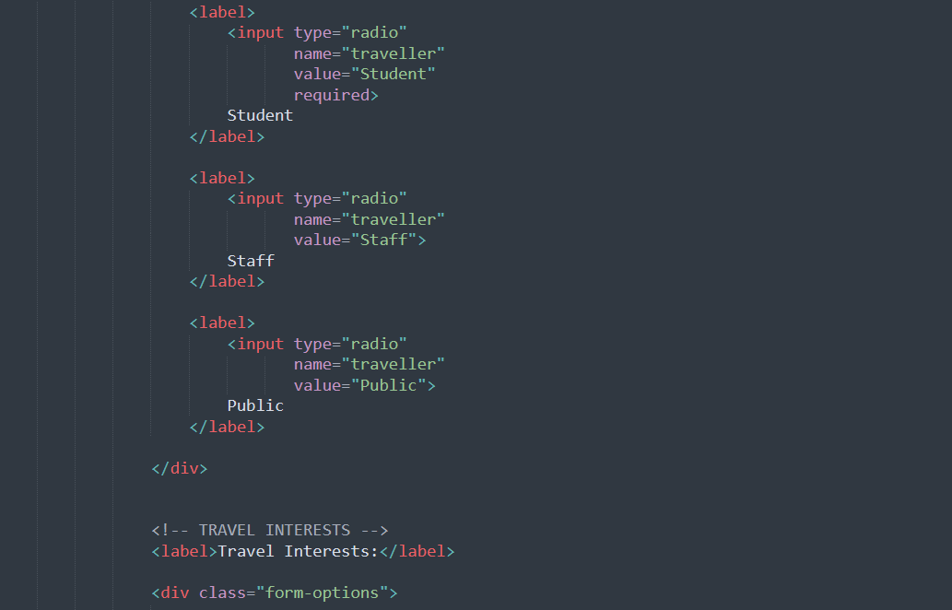

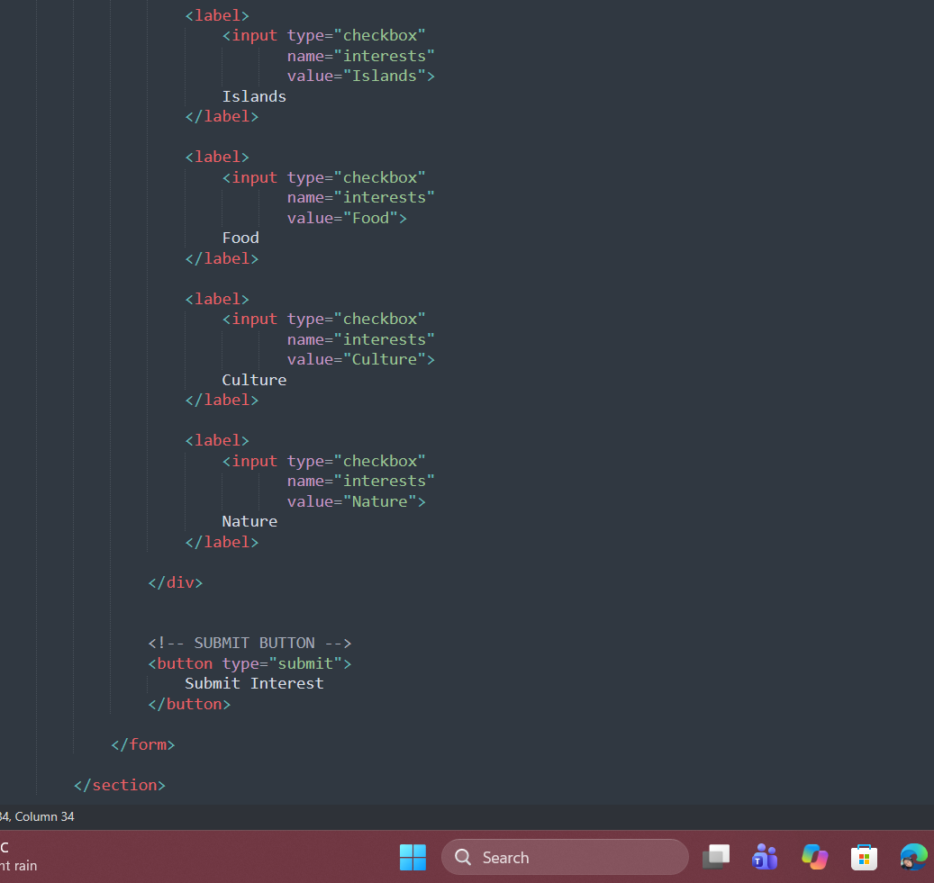
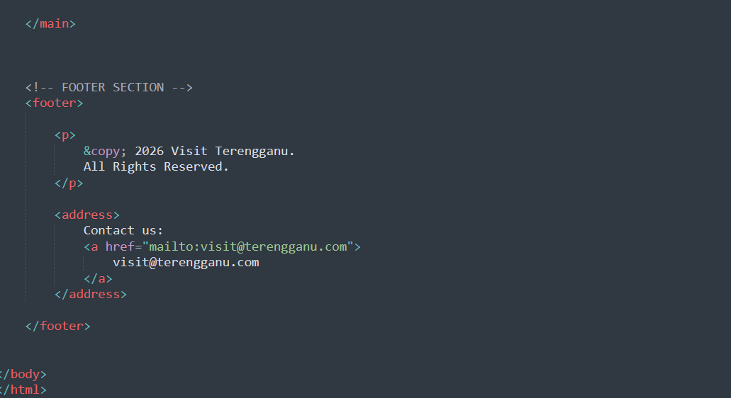

Style.css

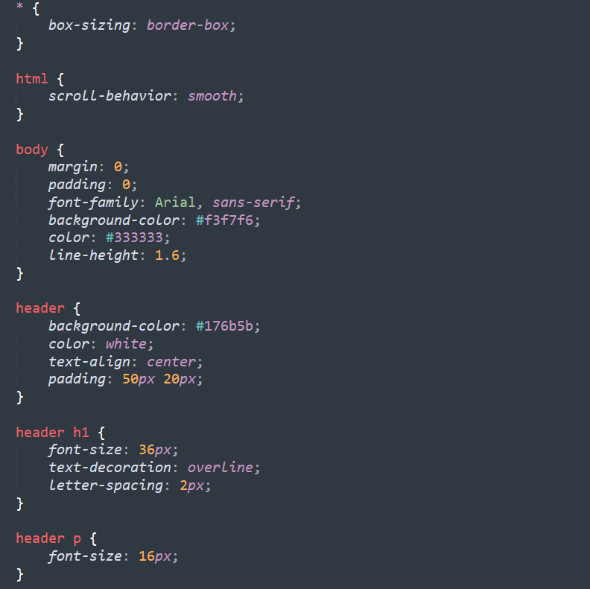
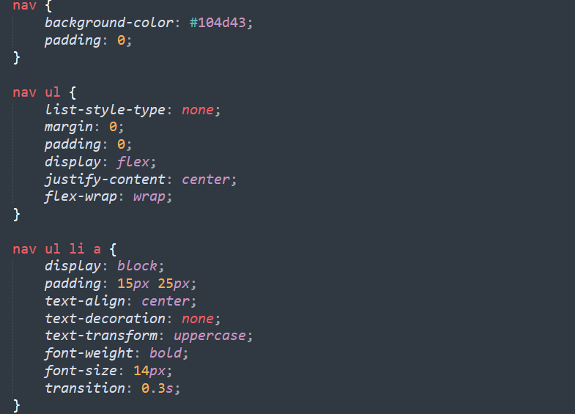

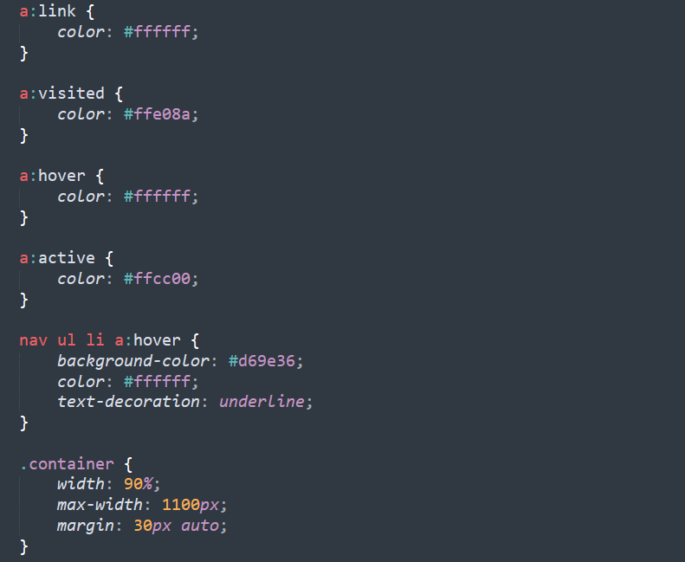
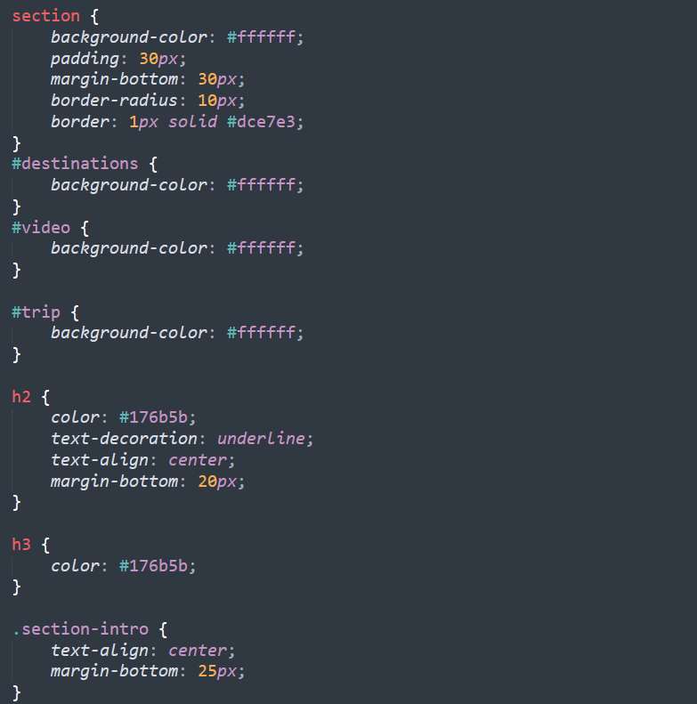

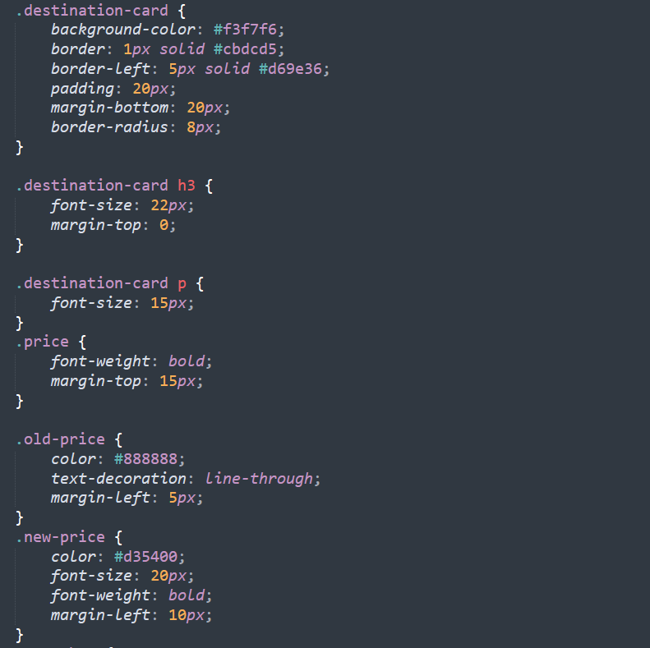
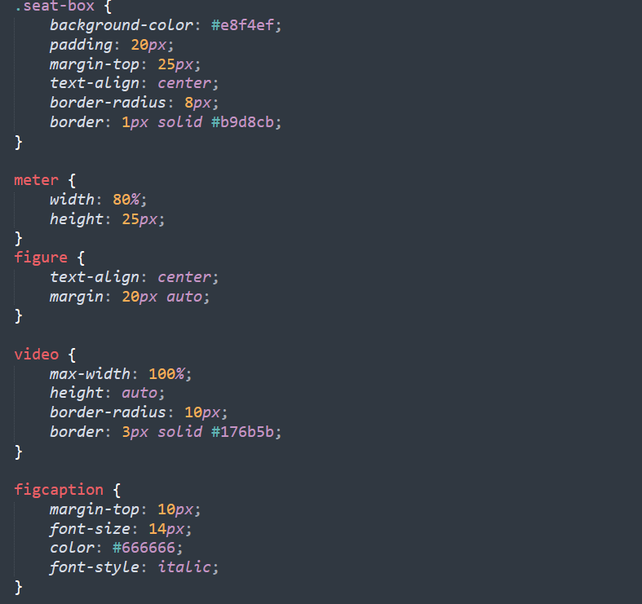

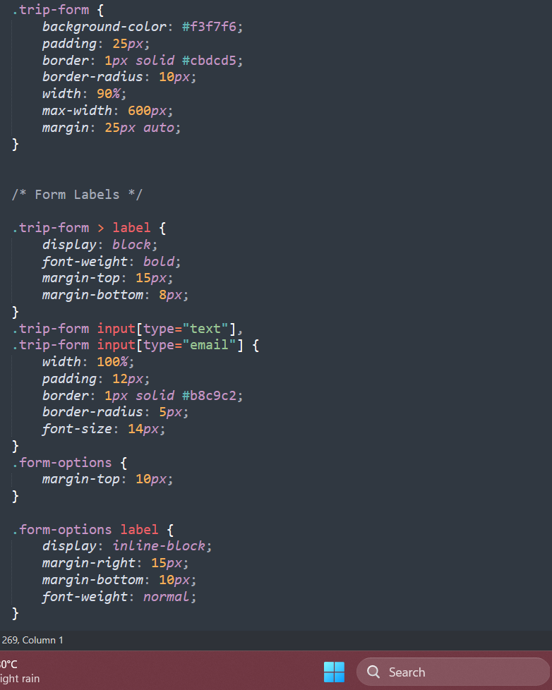
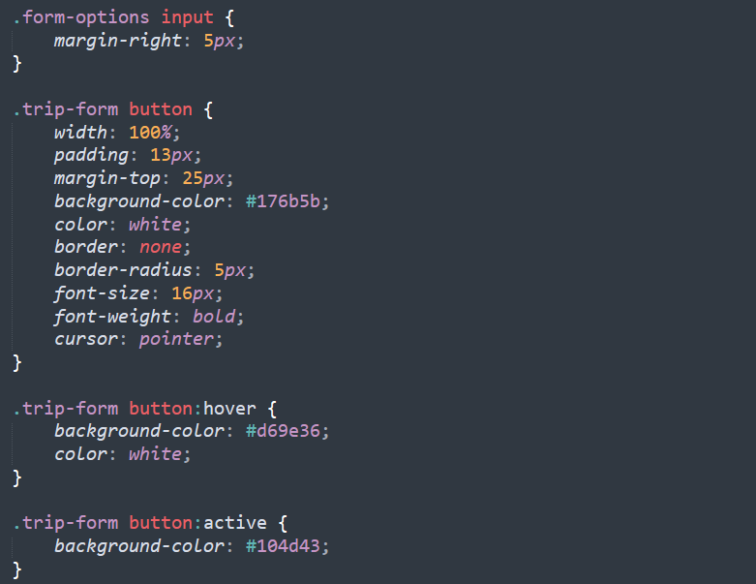

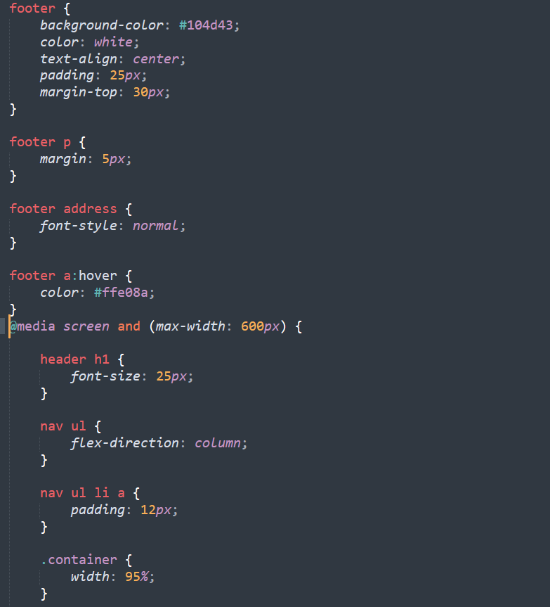
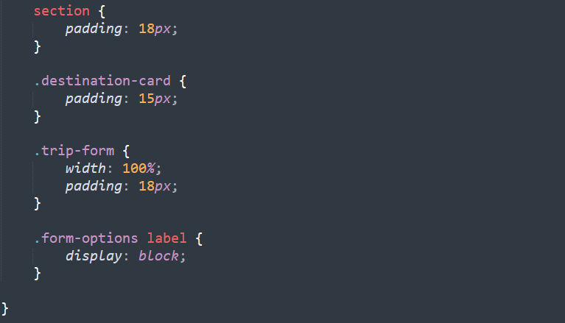

Output

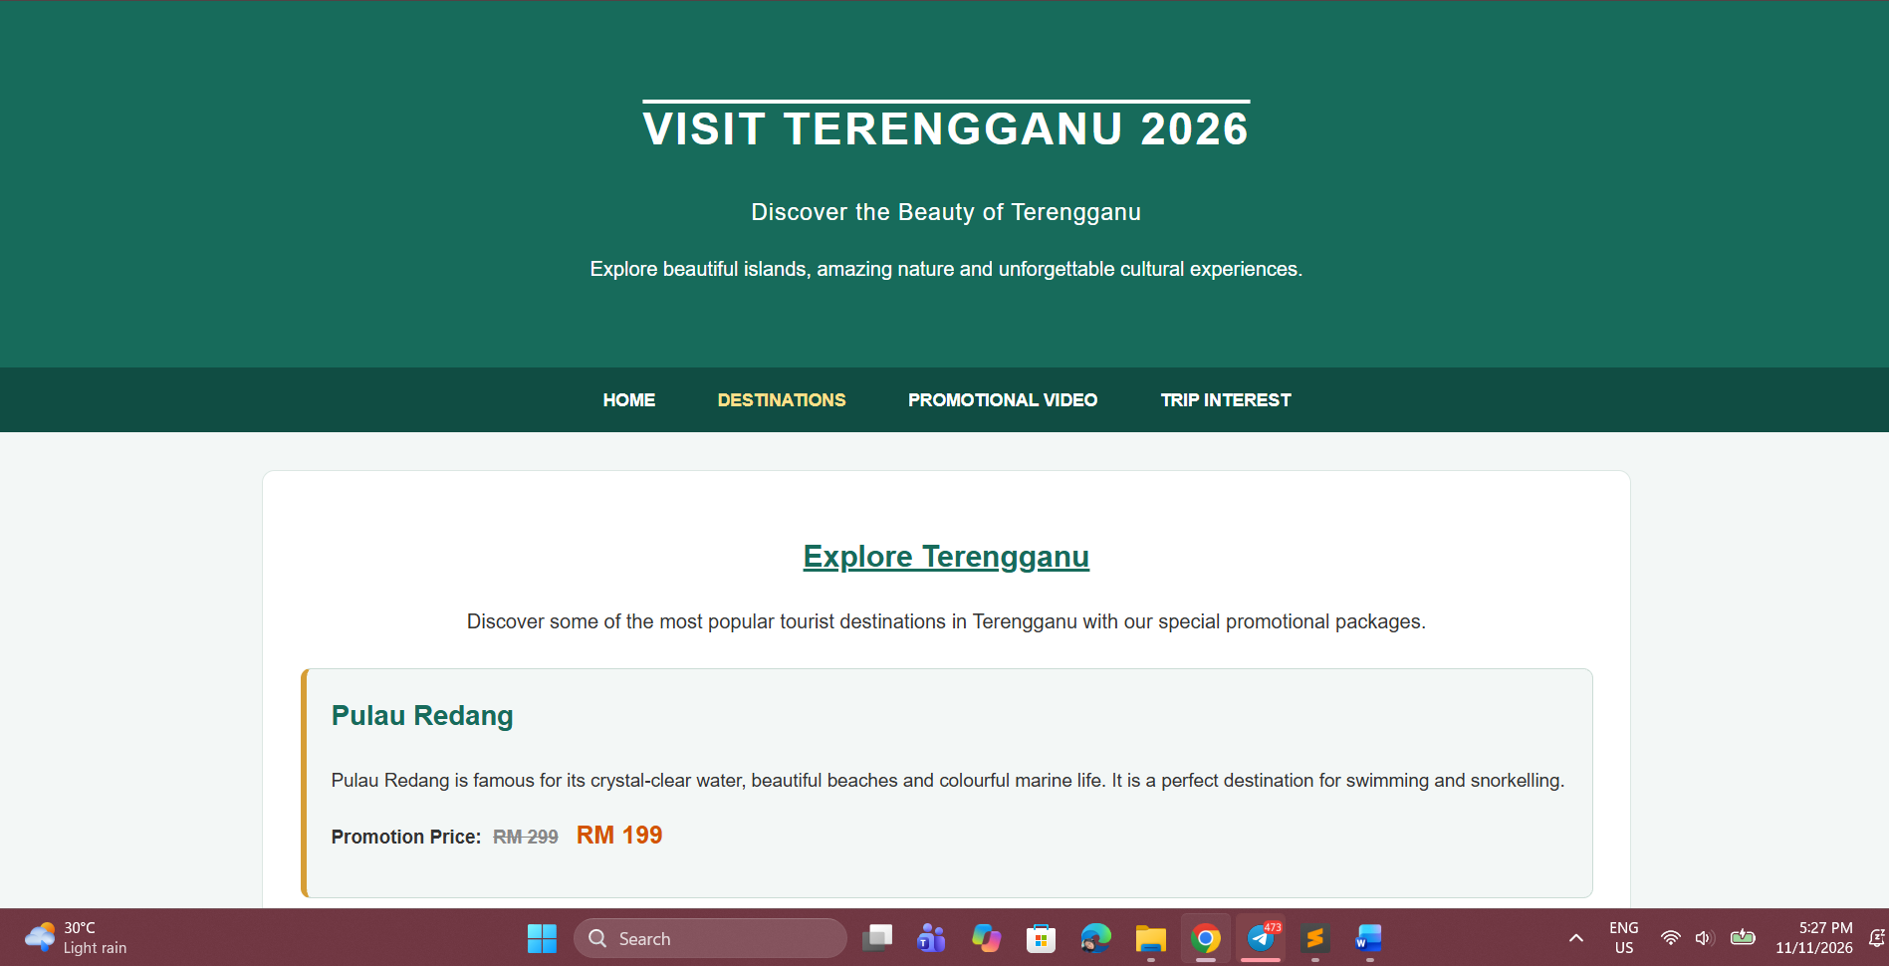
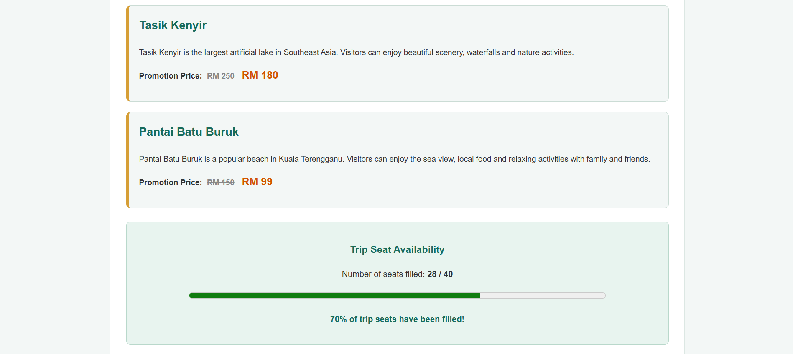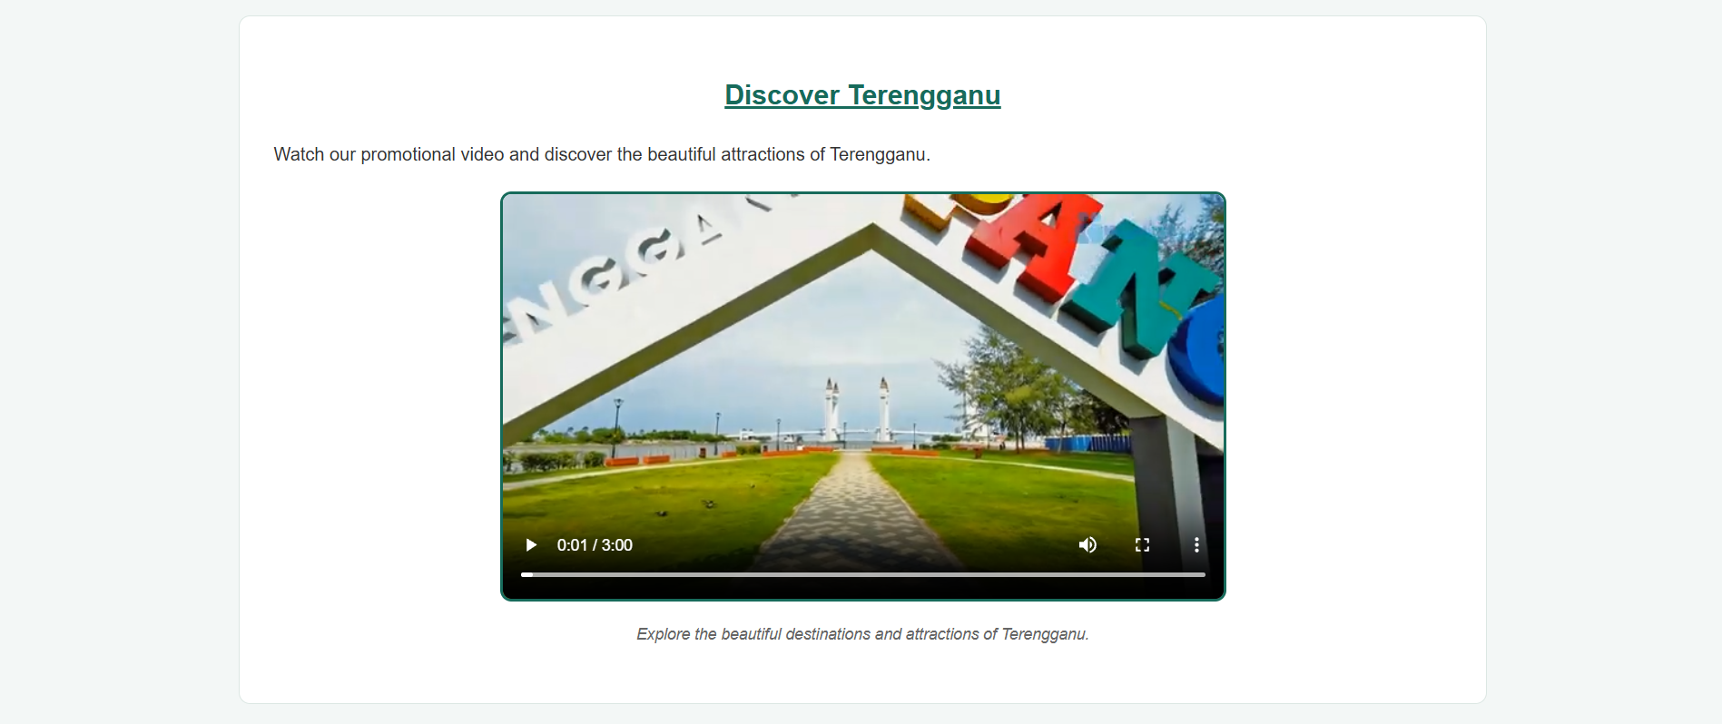
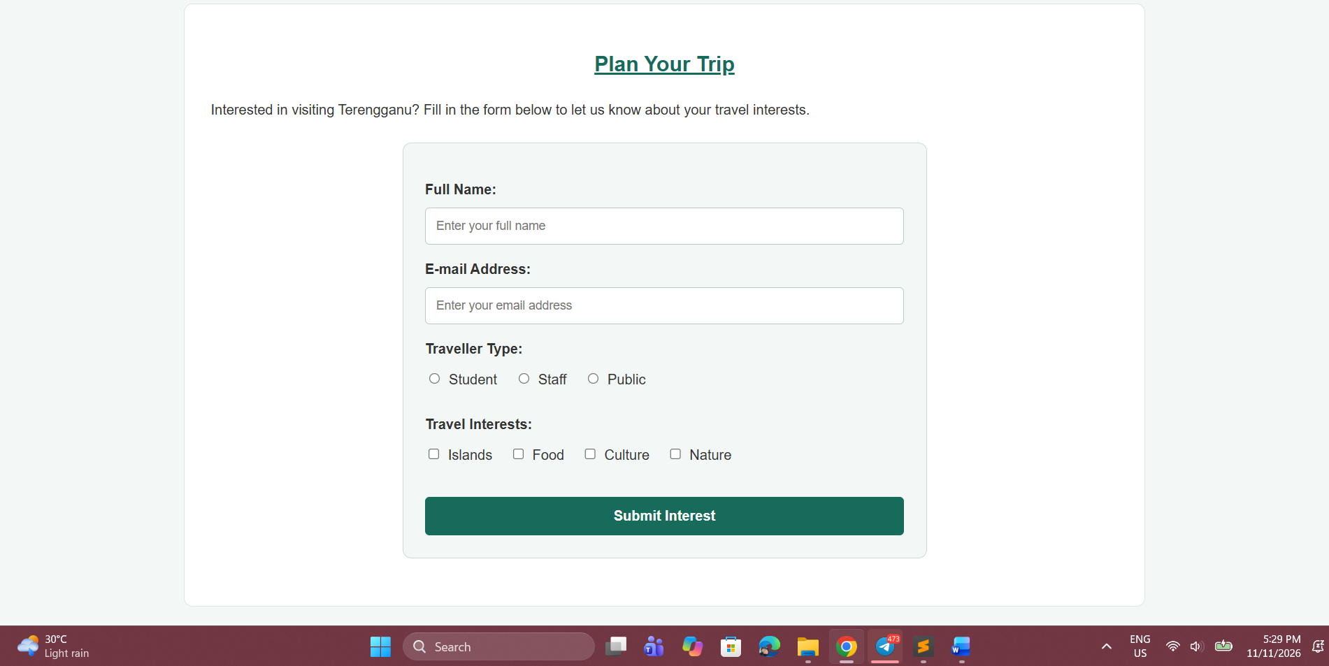

HTML Checker

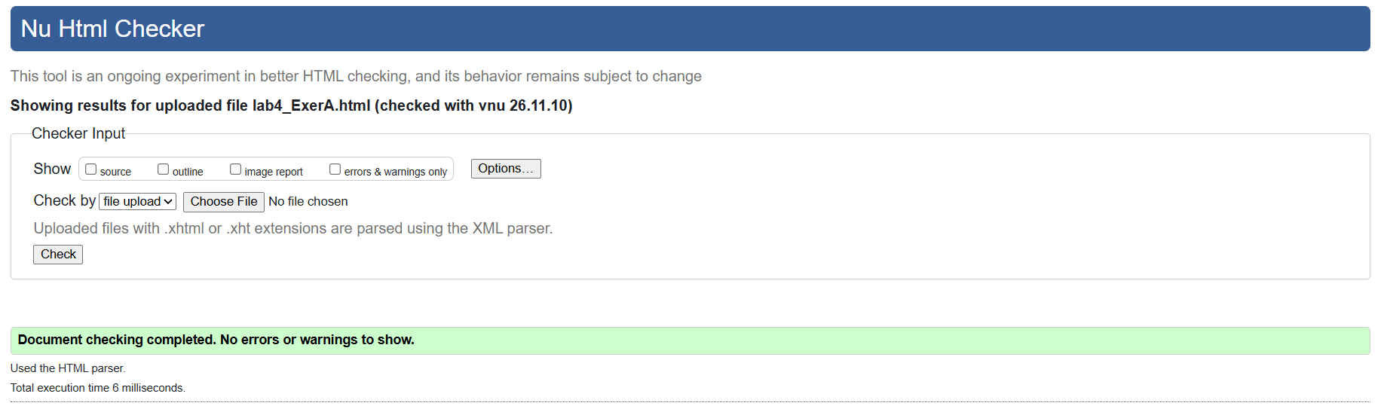

Problem B: e-Café Campus (Debugging and Extend)

The campus café has a promotional page, but it does not look as expected: the menu still shows bullet points, the heading has no line above it, the prices are not highlighted, the hover colour does not work on visited links, the “Menu” link does nothing and the video cannot be played. Find and fix the errors, then extend the page.

Given Code

- <!DOCTYPE html>
- <html lang="en">
- <head>
- <meta charset="utf-8">
- <title>e-Café Campus</title>
- <style type="text/css">
- <!-- Navigation bar -->
- ul {
- list-style-type: no;
- margin: 0;
- padding: 0;
12 }
- a:link {color: #1A5276;}
- a:hover {color: #E67E22;}
- a:visited {color: #7D3C98;}
- a:active {color: #C0392B;}
- h1 {text-decoration: overlined;}
- p {color #333333; text-align: justify;}
- #intro {
- font-size: 18px;
- background-color: #FDEBD0;
- highlight {
- font-weight: bold;
- color: #C0392B;
25 }
- </style>
- </head>
- <body>
- <header>
- <h1>e-Café Campus</h1>
- </header>
- <nav>
- <ul>
- <li><a href="menu">Menu</a></li>
- <li><a href="#video">Video</a></li>
- <li><a href="#contact">Contact</a></li>
37 </ul>
- </nav>
- <section id="menu">
- <h2>Today's Menu</h2>
- <p class="intro">Freshly brewed coffee and local delights every day.</p>
- <article id="item">
- <h3>Kopi Tarik</h3>
- <p>Only <span class="highlight">RM 3.50</span></p>
- </article>
- <article id="item">

- <h3>Nasi Lemak</h3>
- <p>Only <span class="highlight">RM 5.00</span></p>
- </article>
- </section>
- <section id="video">
- <h2>Watch Our Story</h2>
- <video width="400" height="300">
- <source src="cafe.mp4" type="mp4">
- Your browser does not support the video tag.
- </video>
- </section>
- <footer id="contact">
- <p>&copy; 2026 e-Café Campus</p>
- </footer>
- </body>
- </html>

Instructions
Part 1. Find and Fix the Errors
- Copy the given code into a new file named lab4_ExerB.html.
- Identify and correct all errors (at least 8). At the top of the <body>, write an HTML comment listing each error and the line number, e.g. <!-- Error 1 (Line 9): ... -->.
- Test the page: the menu has no bullet points, the <h1> has a line above it, the prices are bold and red, the “Menu” link jumps to the menu section, the hover colour works on all links, and the video can be played.
- Validate your corrected file at https://validator.w3.org and your CSS at https://jigsaw.w3.org/css-validator. Your final page must show no errors.

Part 2. Extend the Existing Page
- Create an external style sheet named cafe.css and link it to the page. Move the navigation bar styles into this file, then style the navigation bar: links displayed as blocks (display: block or inline-block), background-color, padding, text-transform: uppercase, text-decoration: none, and a different background colour on :hover.
- Add a promotion to each menu item: show the old price using a class .old-price with text-decoration: line-through, followed by the new price (e.g. RM 4.50 crossed out, followed by RM 3.50).
- Add a caption below the video using <figure> and <figcaption>. Add the viewport
<meta> tag and make the video responsive with max-width: 100% and height: auto.
- Add a new <section id="feedback"> with a form containing: Name, E-mail, Visit type (radio: Dine-in, Take-away), Favourite items (at least 3 checkboxes) and a Submit button. Style the form using a class .feedback-form, and add a link to this section in the navigation bar.

- In the footer, add an <address> element with an e-mail link (mailto:).
- Use comments to explain each new section of your HTML and CSS code.

Submission
Save the files as lab4_ExerB.html and cafe.css, validate them at https://validator.w3.org and https://jigsaw.w3.org/css-validator (Validate by File Upload), and submit them (Submit lab4_ExerB.html, cafe.css and Screenshot of validation) through Github

Codes

Lab4_ExerB.html

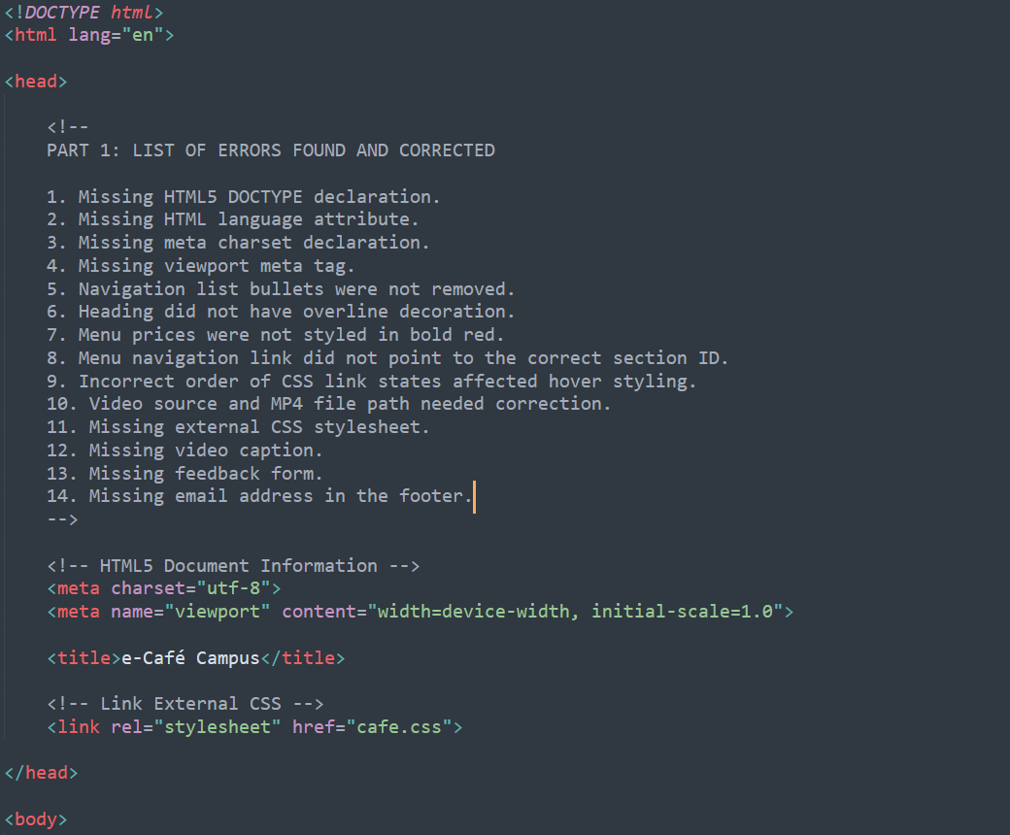
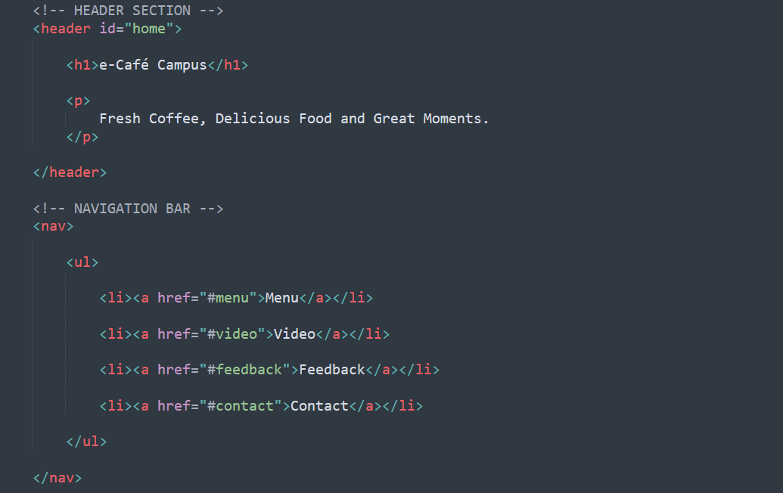
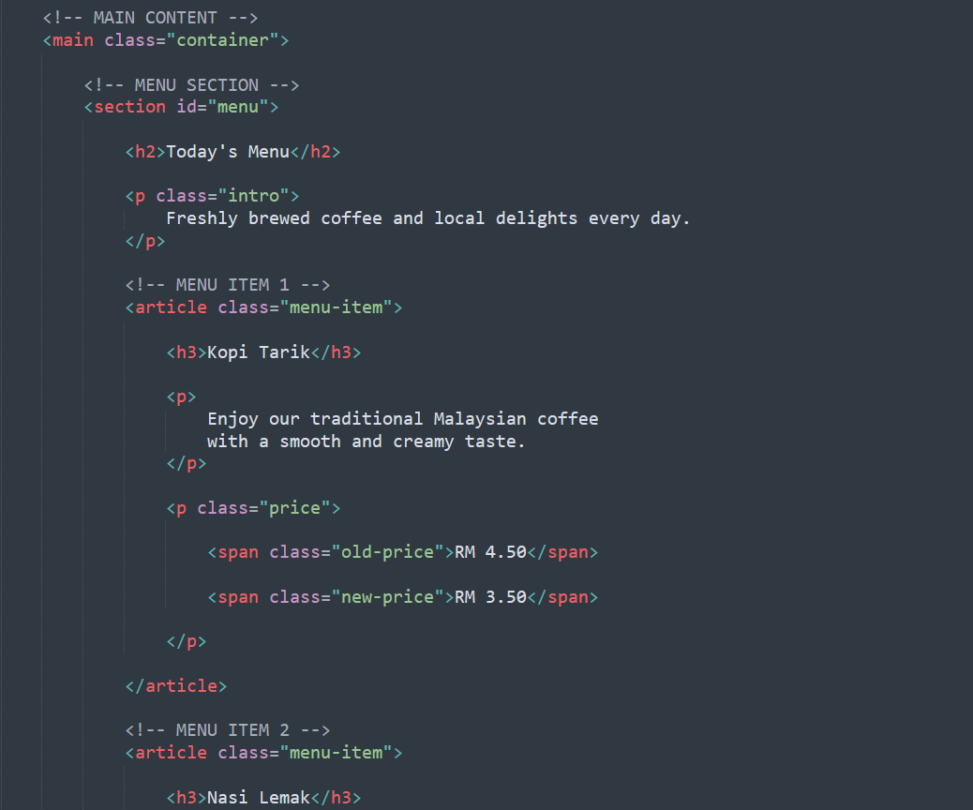
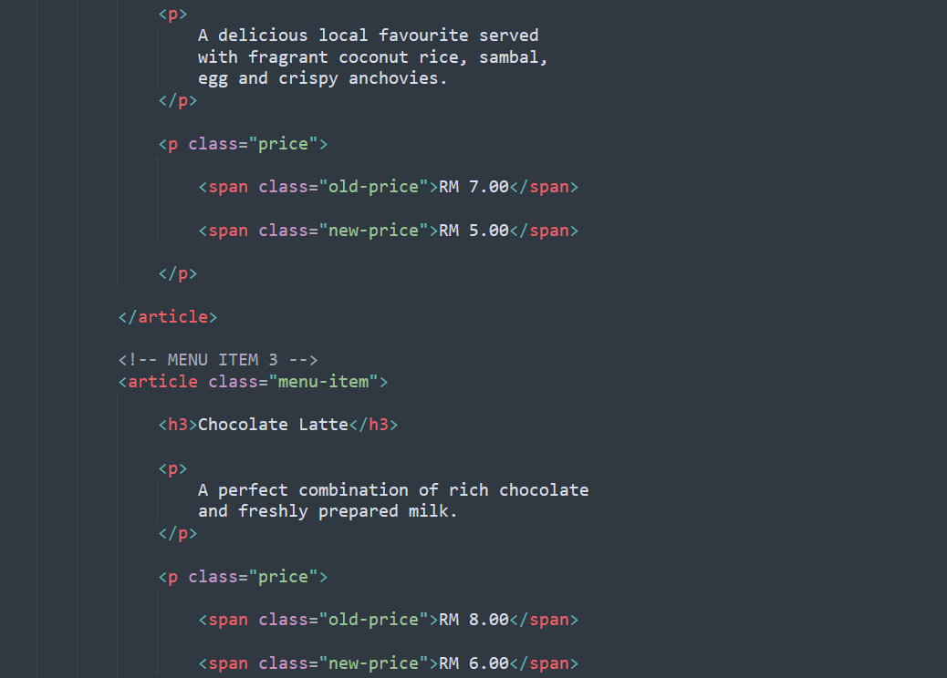
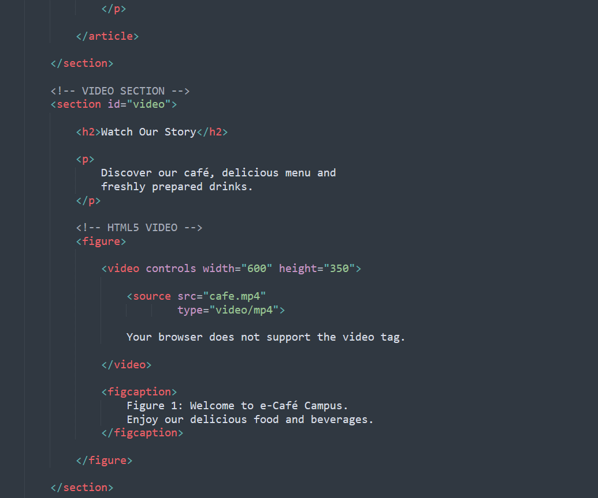
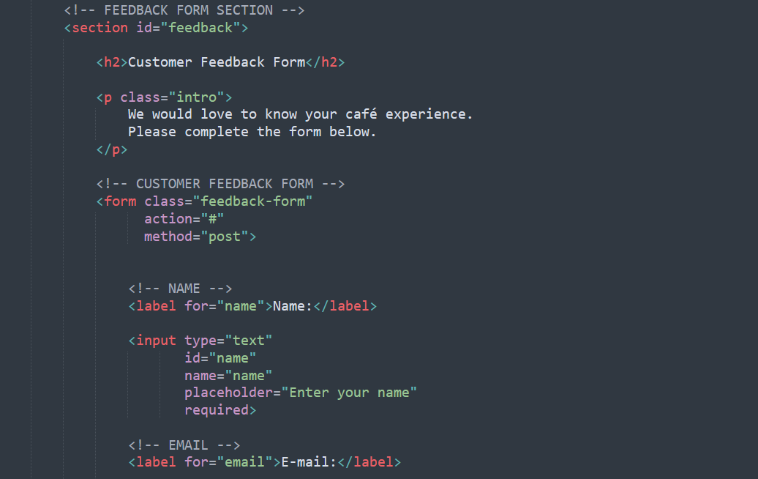
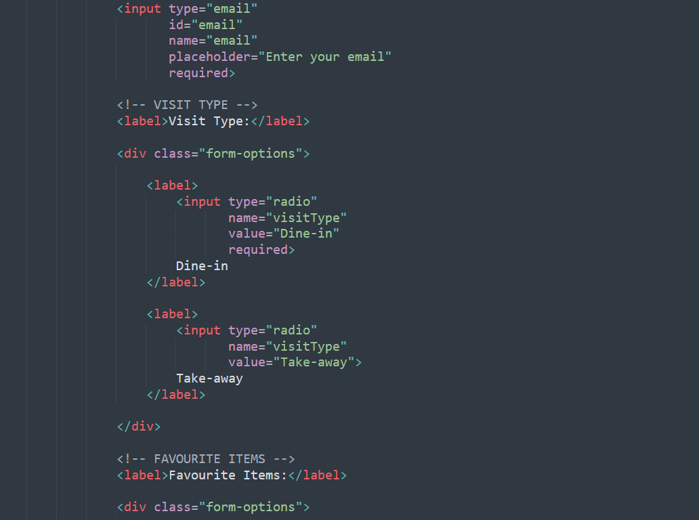
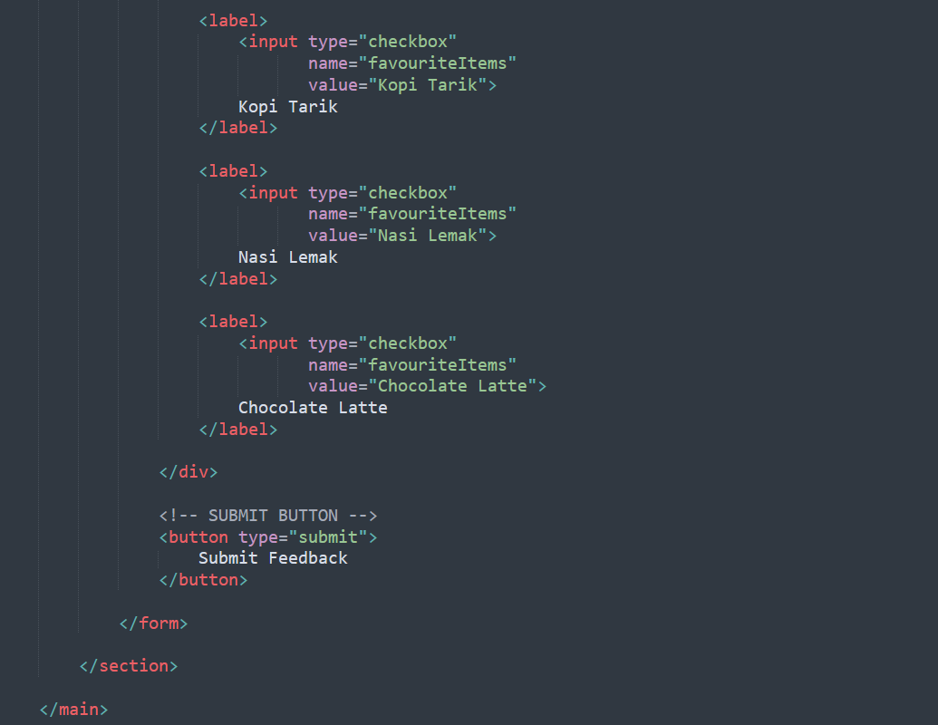
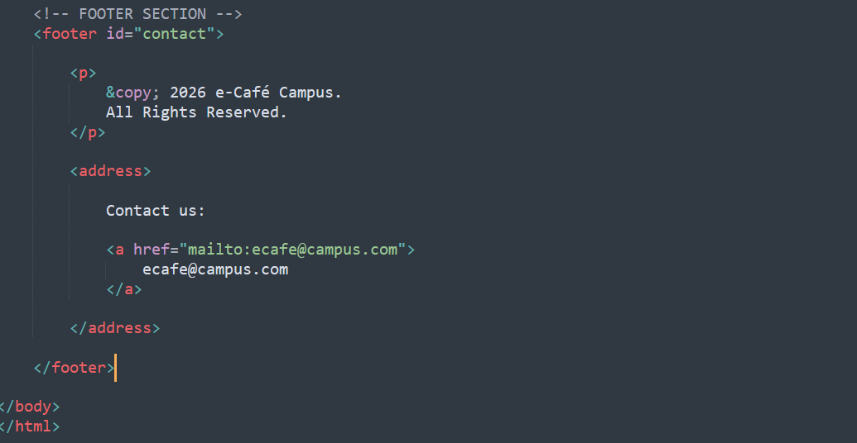

Café.css

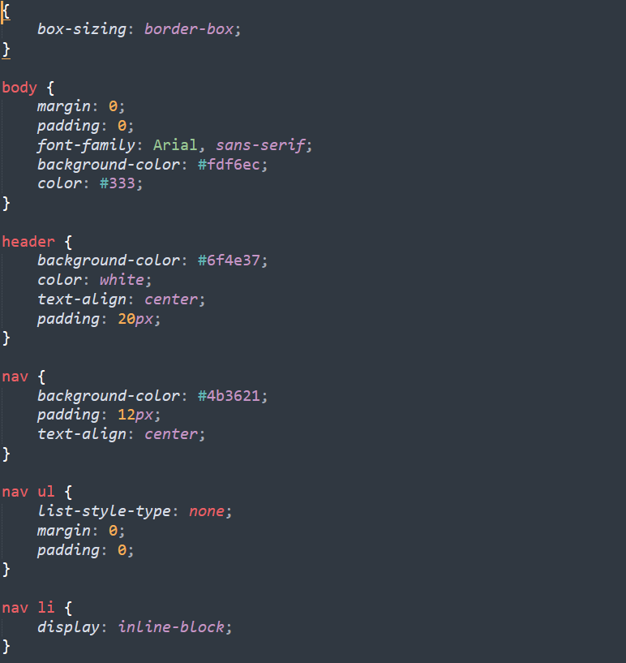
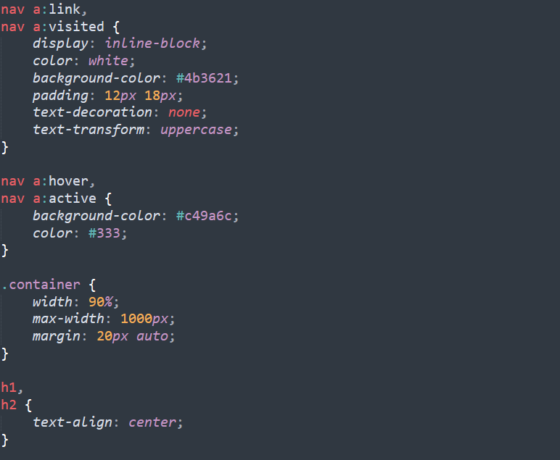
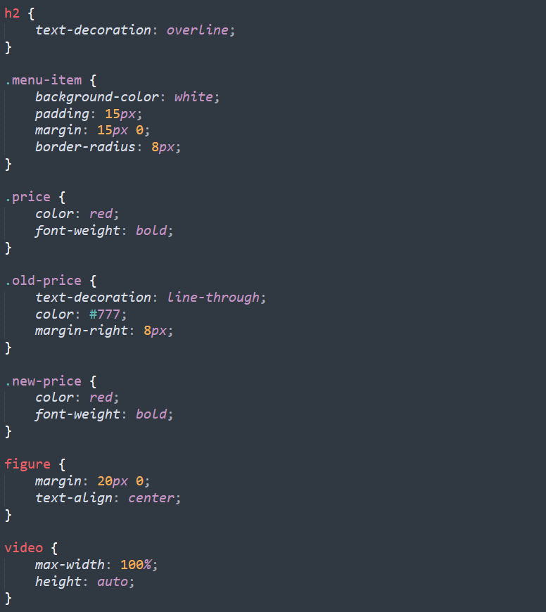
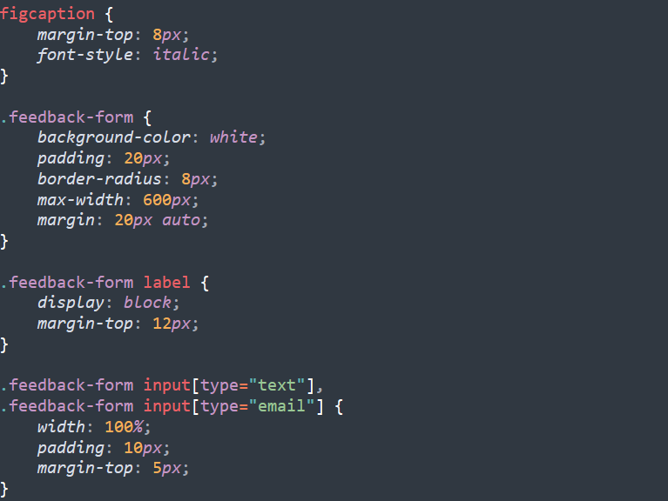
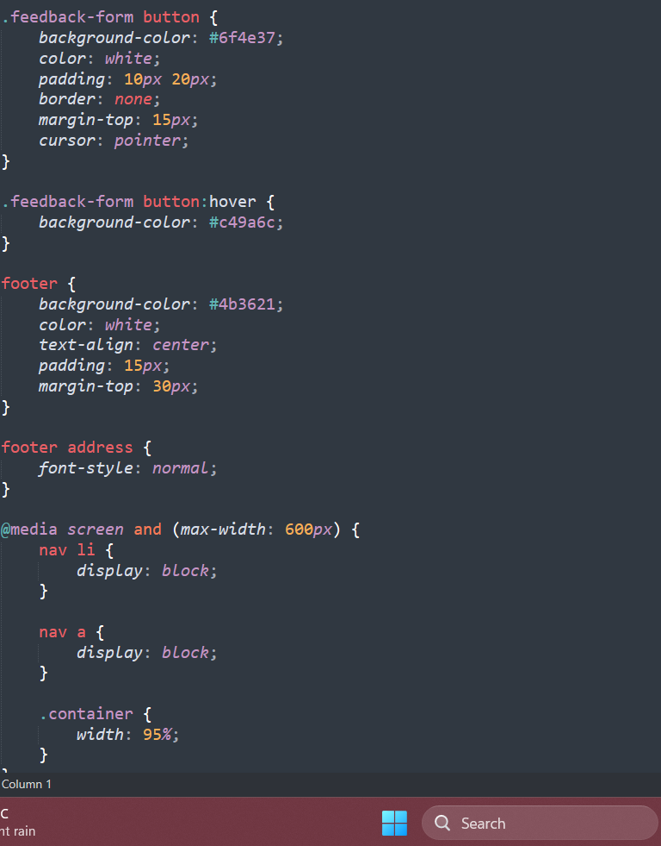

Output

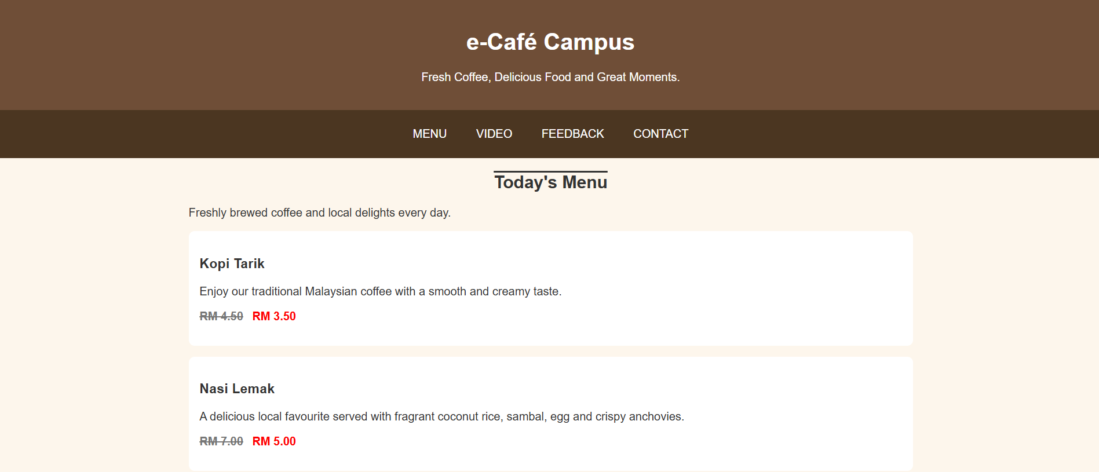
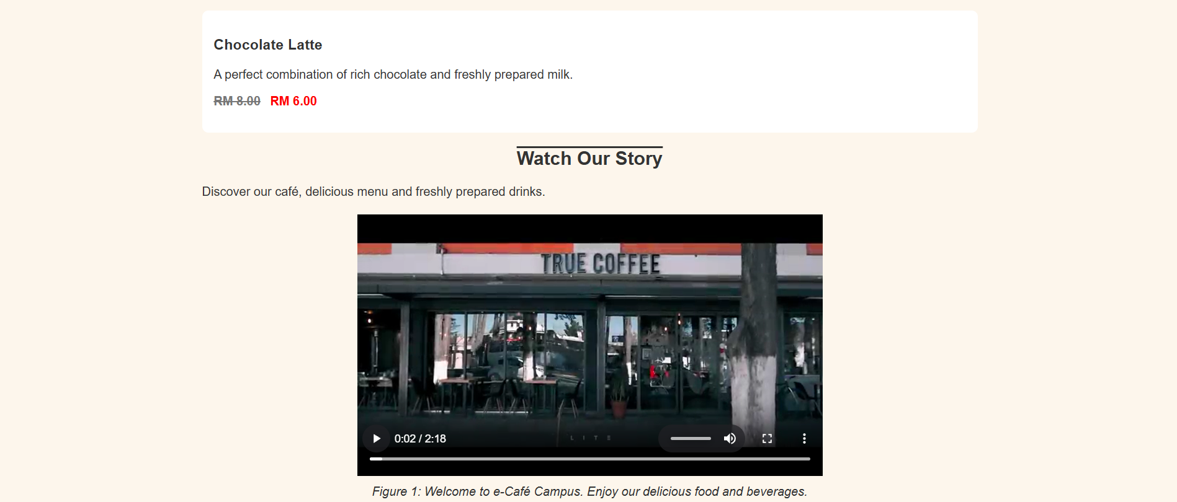
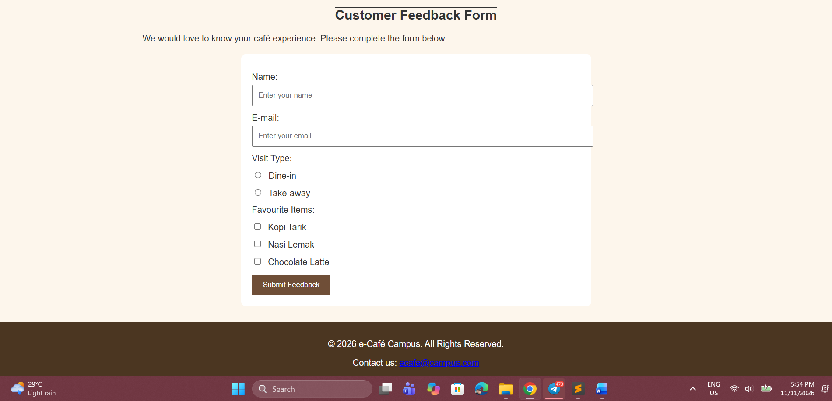

HTML Checker

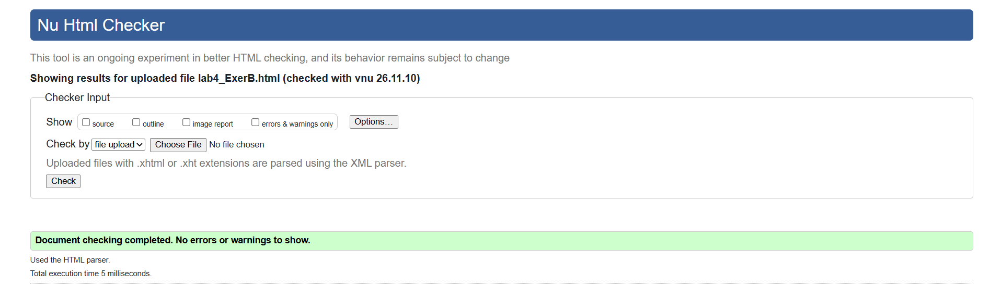

Rubric
Table A: Rubric for Additional Lab Exercise 4 – Problem A

Criteria | Excellent (5) | Good (4) | Average (2–3) | Needs Improvement (0–1)
HTML5 Structure | All semantic tags (header, nav, section, article, footer, address, meter) are correctly used.  Structure is clear and logical. | Semantic tags are mostly used correctly. Structure is good. | Some semantic tags used incorrectly or missing. | Minimal or no use of semantic tags.
Navigation Bar | Built with <ul> and styled in external CSS; no bullets or underline; hover effect works; all links jump to the correct sections. | Functional, but design could be improved. | Navigation bar present but not fully functional (e.g. some links broken). | Navigation bar missing or poorly implemented.
Video Embedding | Video correctly embedded with controls, correct source type, fallback text and a caption; scales on small screens. | Video embedded and functional, minor styling issues. | Video embedded but lacks caption, controls or proper styling. | No video or improperly embedded.
Form Design & Function | Form is complete (name, e-mail, radio, checkboxes, submit), well-structured and styled with a class. | Form is functional with minor styling issues. | Form is present but missing some elements. | Form is incomplete or missing.
CSS Styling | Effective use of internal and external CSS, at least 2 ID and 2 class selectors and 6 properties. Creative and consistent styling. | CSS applied but lacks creativity or consistency. | Some CSS applied but minimal effort shown. | Little or no CSS applied.
Text Decorations | Proper and creative use of overline, underline and line-through (old price) across headings and links. | text-decoration used correctly but without creativity. | Minimal use of text-decoration. | No use of text-decoration.
Interactive Link States | All four link states styled in the correct order and fully functional. | Link states are functional but need more styling. | Link states applied with minimal effort or wrong order. | No link states applied.

Criteria | Excellent (5) | Good (4) | Average (2–3) | Needs Improvement (0–1)
Responsiveness & Design | Page fits small screens (viewport meta, % widths, responsive video) and is visually appealing. | Page is mostly responsive with minor design issues. | Limited responsiveness, design is basic. | Not responsive, poor design.
Total |  |  |  | 40 marks

Table B: Rubric for Additional Lab Exercise 4 – Problem B

Criteria | Excellent (5) | Good (4) | Average (2–3) | Needs Improvement (0–1)
Error Identification | Identifies at least 8 errors correctly with line numbers and clear explanations. | Identifies 6–7 errors correctly. | Identifies 3–5 errors, or explanations are unclear. | Identifies fewer than 3 errors.
Error Correction & Validation | All errors corrected; page works as described and passes both the HTML and CSS validators. | Most errors corrected with 1–2 remaining validation errors. | Some errors corrected but the page still does not work correctly. | Few or no errors corrected.
External CSS & Navigation Bar | cafe.css correctly linked; navigation bar fully styled with hover effect and working links. | External CSS and navigation bar work with minor styling issues. | External CSS attempted but navigation bar is basic or partly broken. | No external CSS or navigation bar not styled.
Text Decorations & Link States | Old prices use line-through; heading decorations and all four link states work in the correct order. | Text decoration and link states work with minor issues. | Text decoration or link states partly applied. | No text decoration or link states.
Video & Responsiveness | Video plays with controls and caption (figure/figcaption); viewport meta and responsive video applied. | Video and caption work with minor responsive issues. | Video plays but caption or responsiveness missing. | Video still not working.
Form Design & Function | Feedback form complete (name, e-mail, radio, at least 3 checkboxes, submit), styled with .feedback-form and linked in nav. | Form is functional with minor styling issues. | Form is present but missing some elements. | Form is incomplete or missing.
Total |  |  |  | 30 marks

